# Module 2

## Z Test and Normal Distribution

**Question 1:**

A sample of 100 students is taken from a large population. The mean height of the students in this sample is 160 cm. Can it be reasonably regarded that, in the population the mean height is 165 cm, and S.D. is 10 cm? µ

Solution: - By Given Sample Size, n=100, Sample Mean̅

Population Mean µ S.D. of population, σ=10

Since problem is of two tailed test we use following hypothesis

H0: µ

H1: µ n

Sample size is large therefore we use large sample test i.e. z-test

Therefore We use the formula

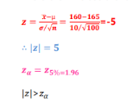

H0 is Rejected H1is accepted

Therefore µ

We can conclude that Population mean is not equal to 165

**Question 2:**

A research team is willing to assume that systolic blood pressure in a certain population of males is approximately normally distributed with S.D. of 16. A simple random sample of 64 males from the population had a mean systolic blood pressure reading of 133.at the 5% LOS. Do these data provide sufficient evidence for us to conclude that the population mean is greater than 130?

Solution: - By Given Sample Size, n=64, Sample Mean̅ ,

Population Mean µ , but in actual solving problem take µ= and

Standard deviation of the population is σ=16

Since problem is of one tailed test we use following hypothesis

H0: µ

H1: µ

Sample size is large therefore we use large sample test Therefore We use the formula

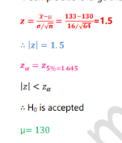

We cannot conclude that Population mean is greater than 130

**Question 3:**

A simple random sample of 16 adult had drawn from a certain population yield a mean weight of 63 kg. Assume that weight in the population is approximately normally distributed with a variance of 49. Does the samples date provide sufficient evidence for us to conclude that a mean weight for the population is less than 70?

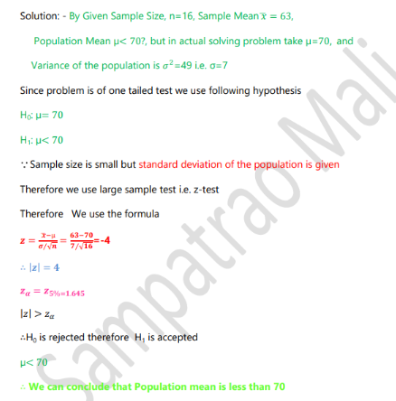

**Question 4:**

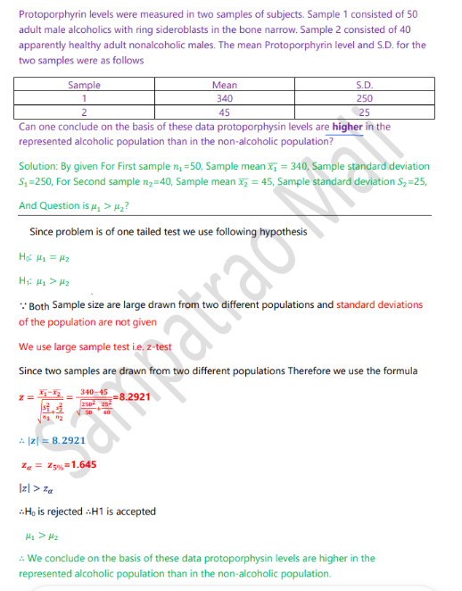

**Question 5:**

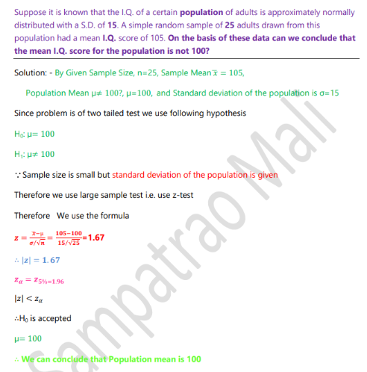

**Question 6:**

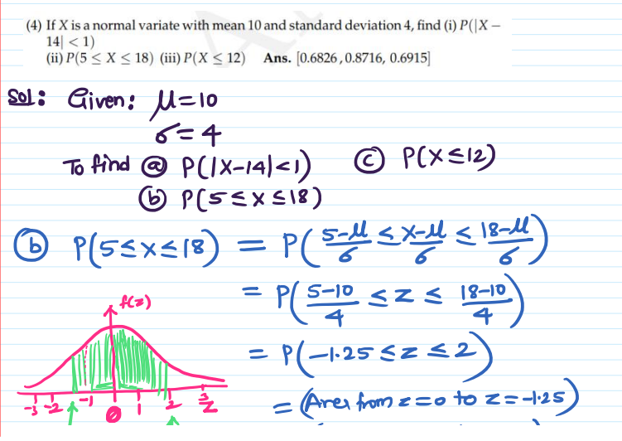

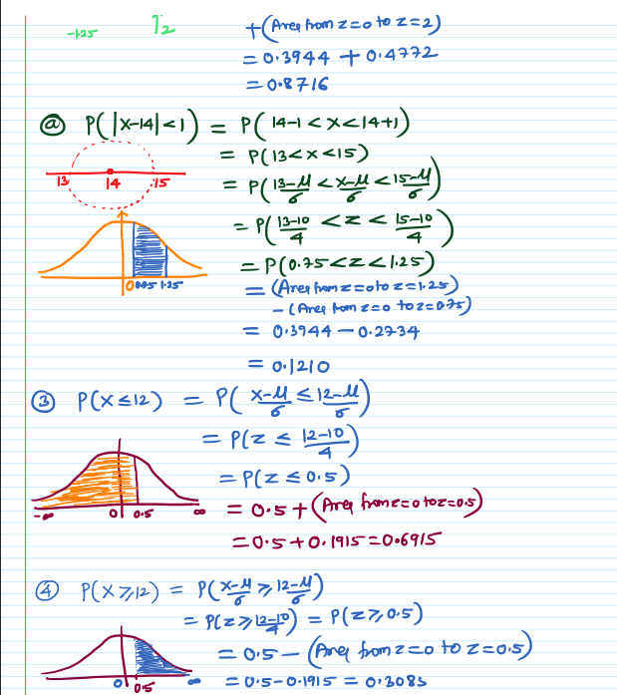

**Question 7:**

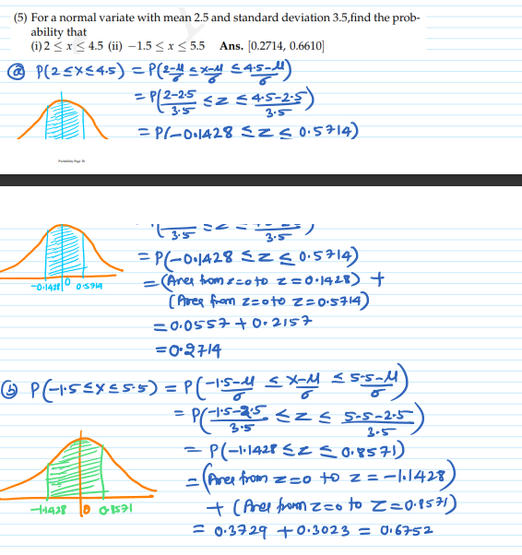

**Question 8:**

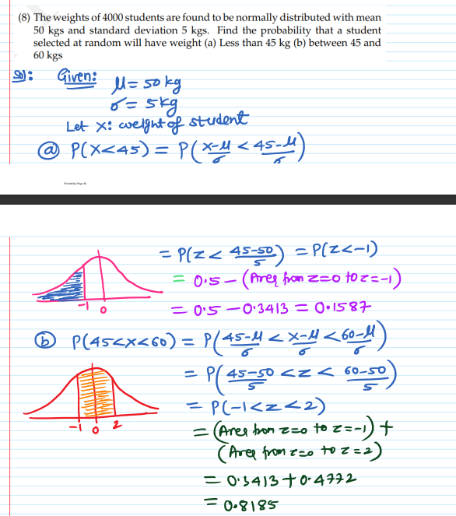

**Question 9**

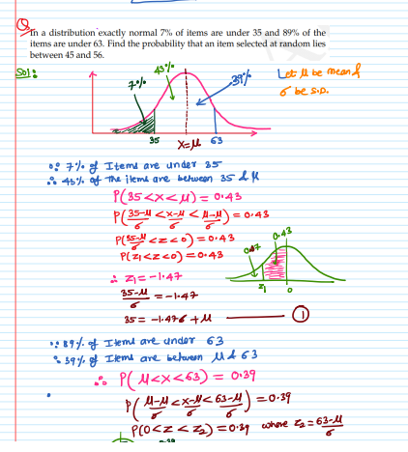

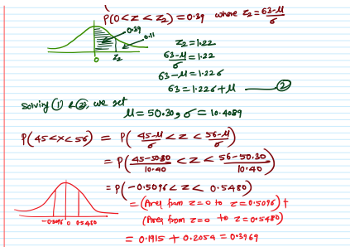

## Chi Square Sums

**Question 1**

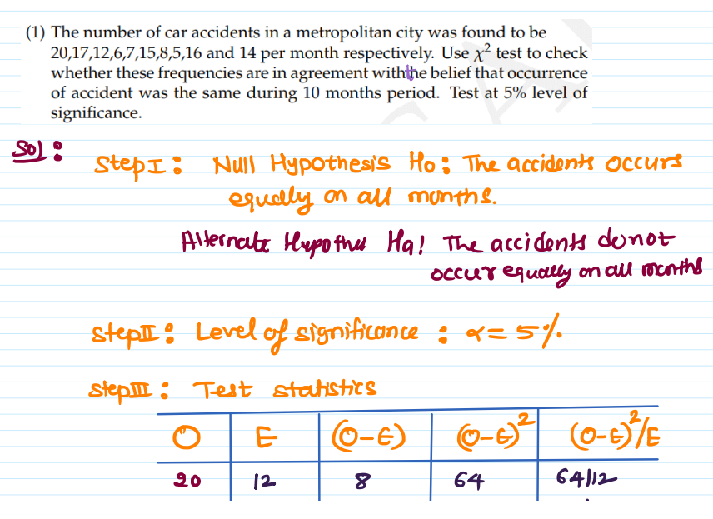

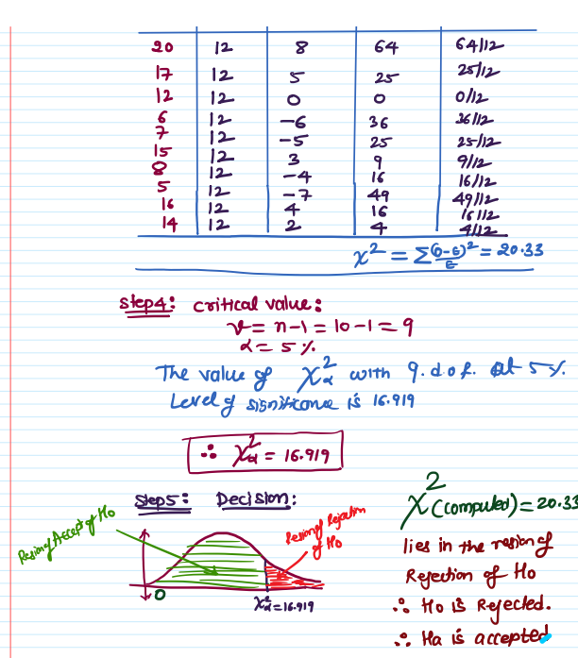

**Question 2**

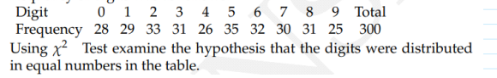

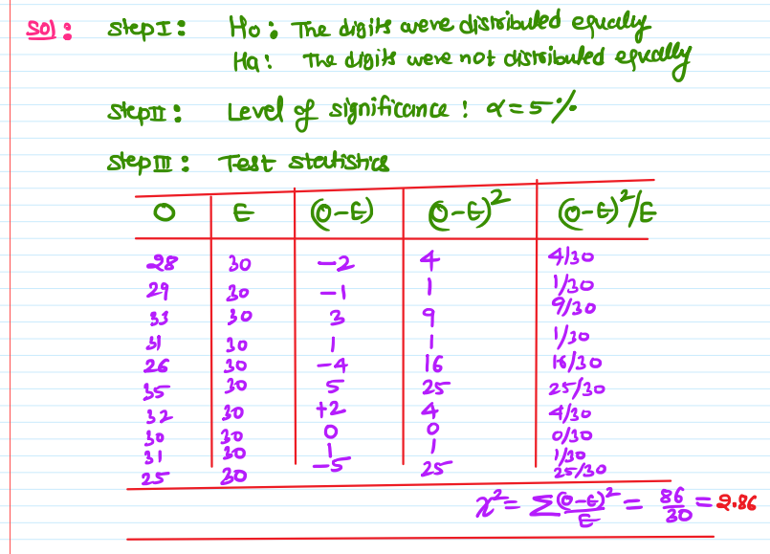

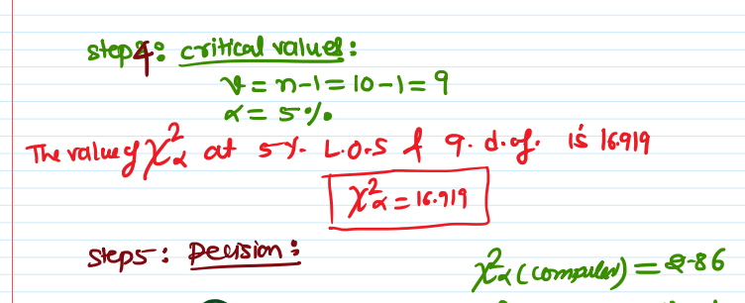

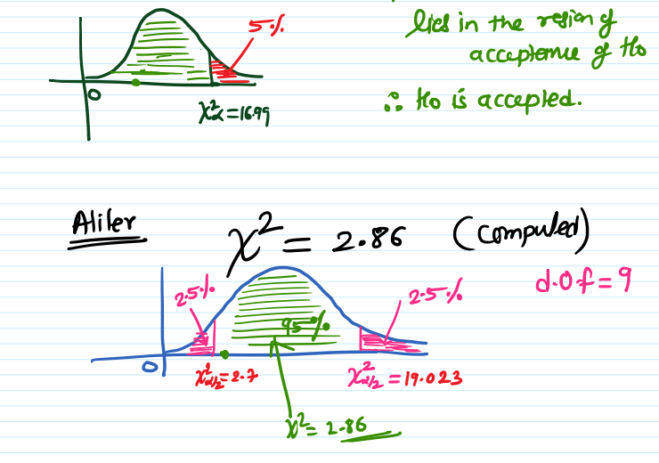

**Question 3:**

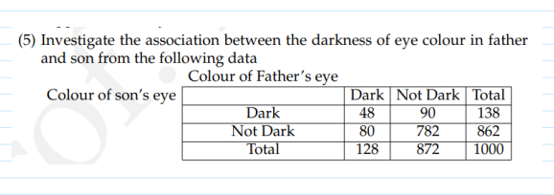



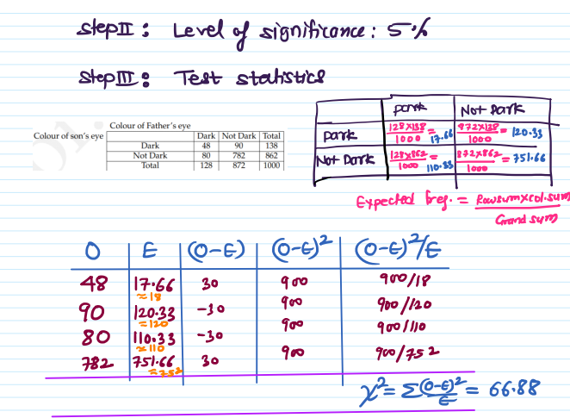

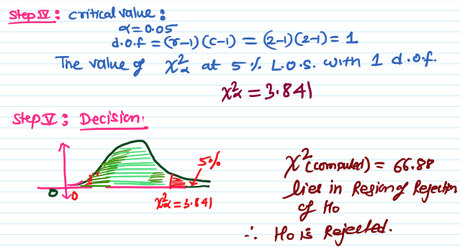

**Question 4**

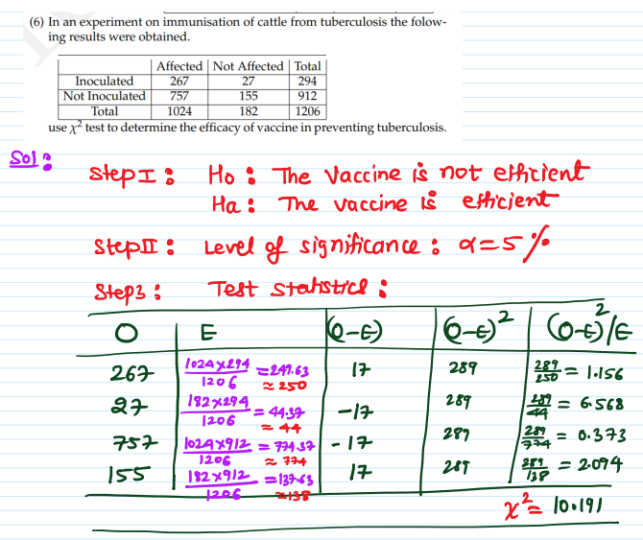

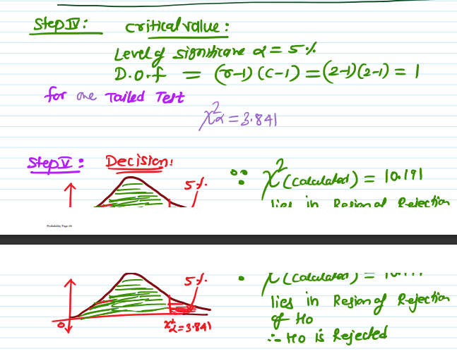

**Question 5:**

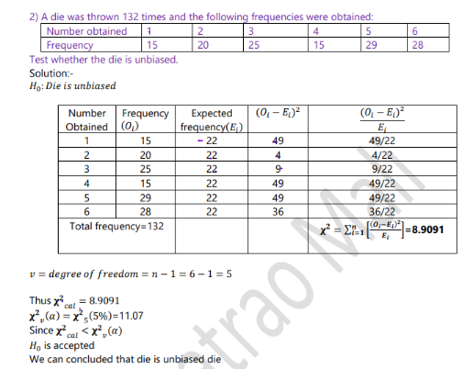

**Question 6:**

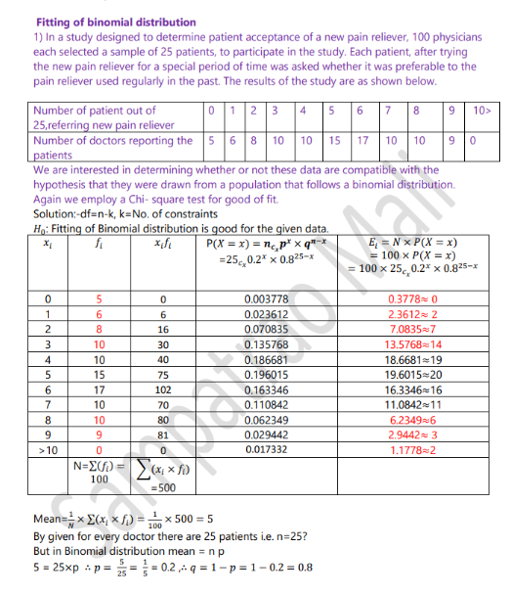

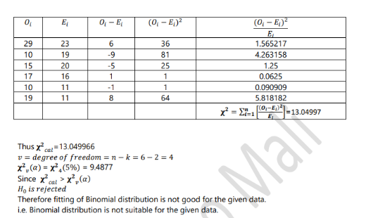

**Question 7**

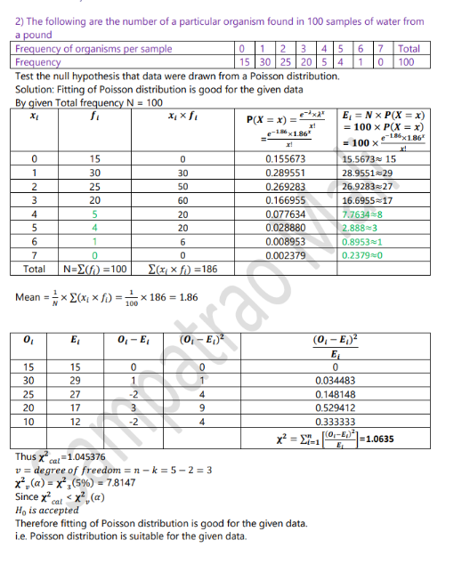

**Question 8**

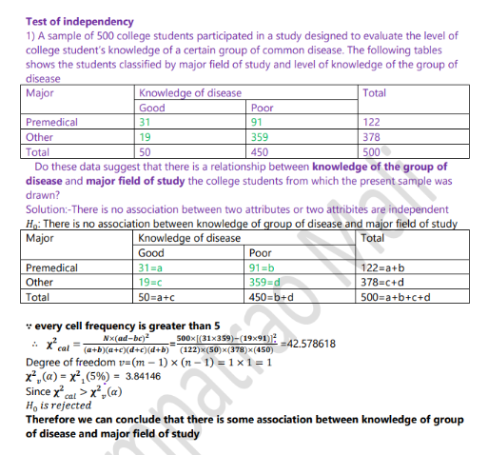

**Question 9**

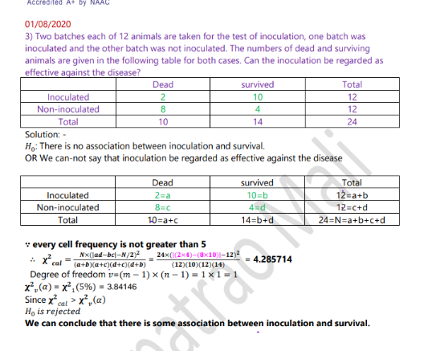

**Question 10**

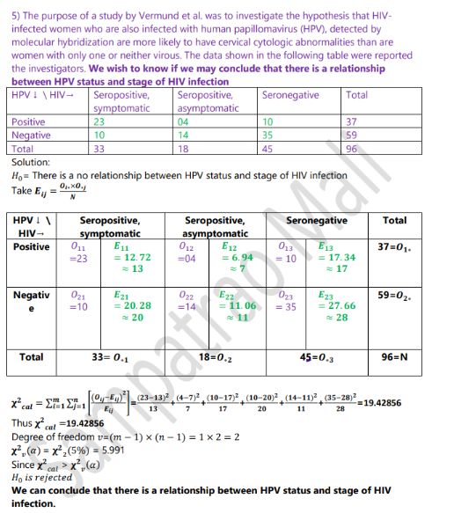

## t Test

**Question 1**

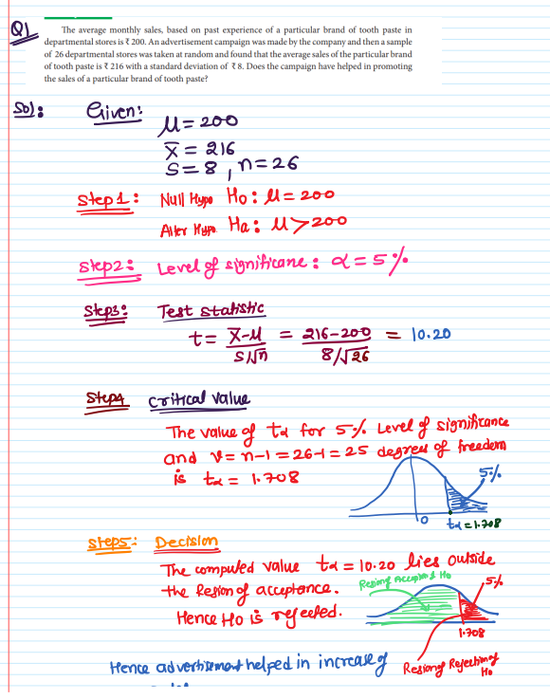

**Question 2**

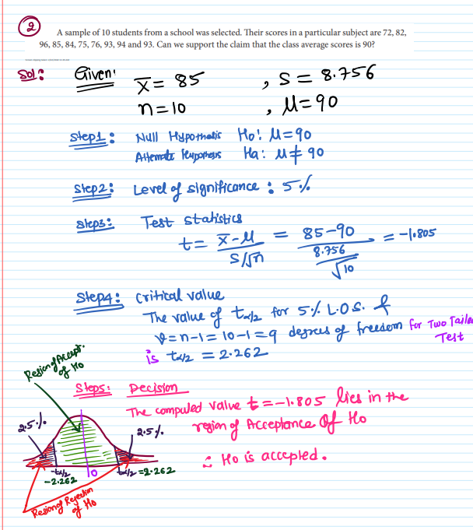

**Question 3**

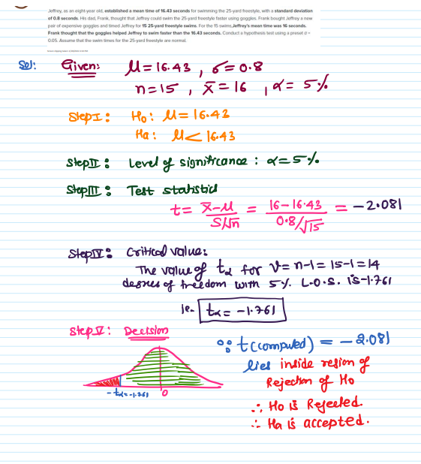

**Question 4**

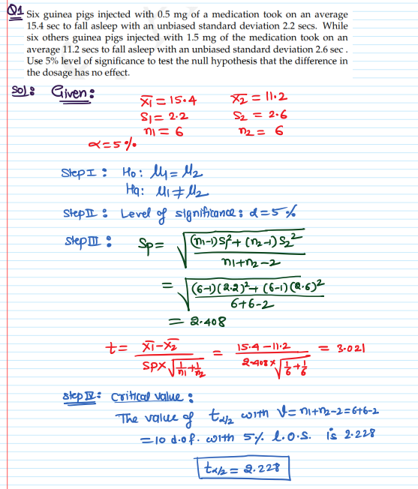

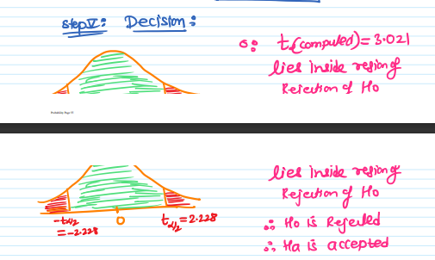

**Question 5**

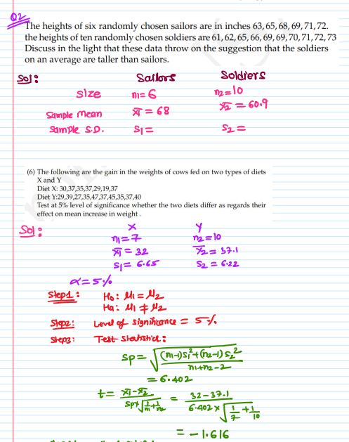

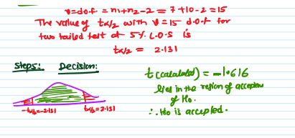

**Question 6**

Test made on breaking strength of 9 pieces of a metal gave the following results:

588, 572, 570, 568, 572, 570, 572, 596, & 584 Test if mean breaking strength of wire can be

assumed as 577?

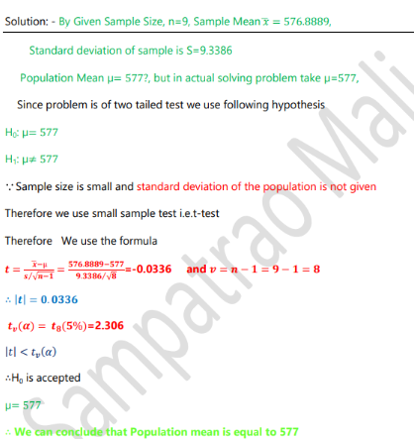

**Question 7**

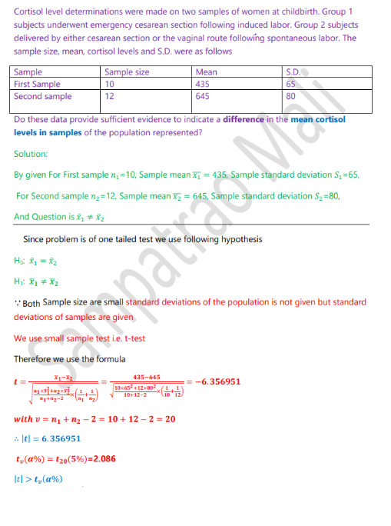

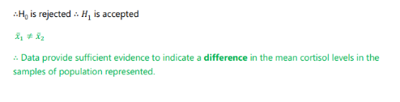

**Question 8**

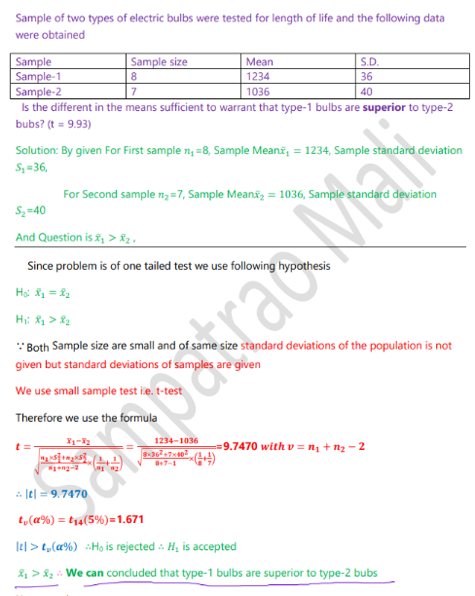

**Question 9**

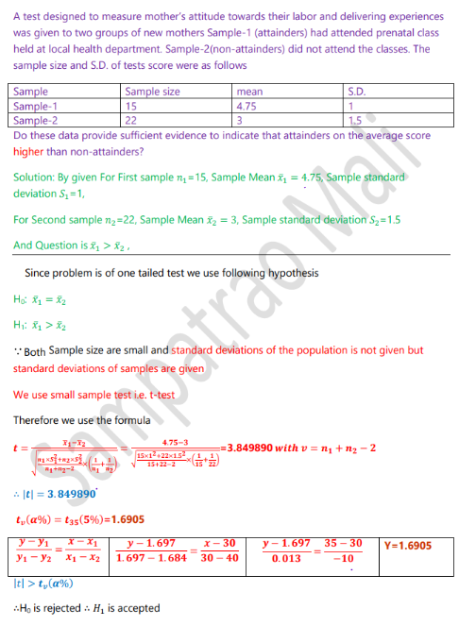



## Poisson Distribution

**Question 1:**

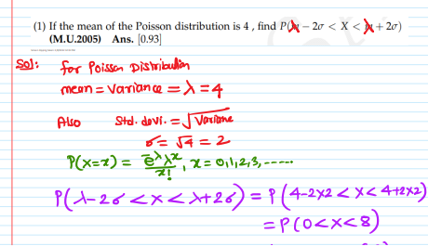

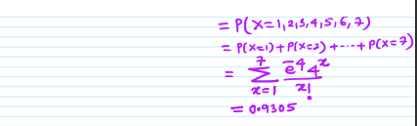

**Question 2:**

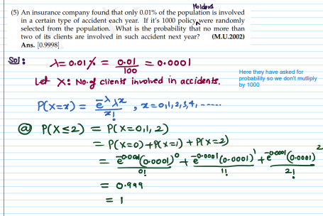

**Question 3:**

